**Challenge Exercises**

*Challenge 1*

Tool:

* Add XY Coordinates

Summary: Adds the fields POINT_X and POINT_Y to the point input features and calculates their values. It also appends the POINT_Z and POINT_M fields if the input features are Z- and M-enabled.

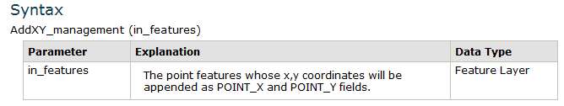

Its parameter required is the in_features.

There are no other optional parameters and deafults.

* Dissolve

Summary: Aggregates features based on specified attributes.

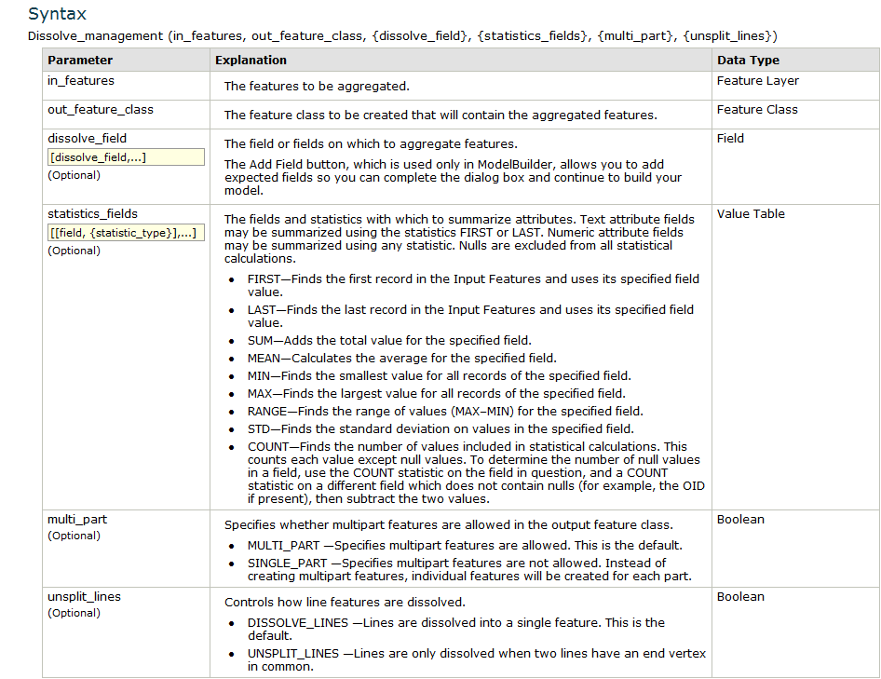

Its Parameters are the in_features, dissolve_field, statistics_field, multi_part, unsplit_lines.

The optional parameters are the [dissolve_field,…], [[field,{statistic_type}],…], multy_part, unsplit_lines. Their defaults is the MULTI_PART and the DISSOLVE_LINES.

*Challenge 2*

Writing a script that runs the Add XY Feature Tool with the hospitals.shp

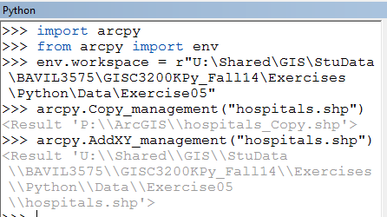

This is the outcome of the map.

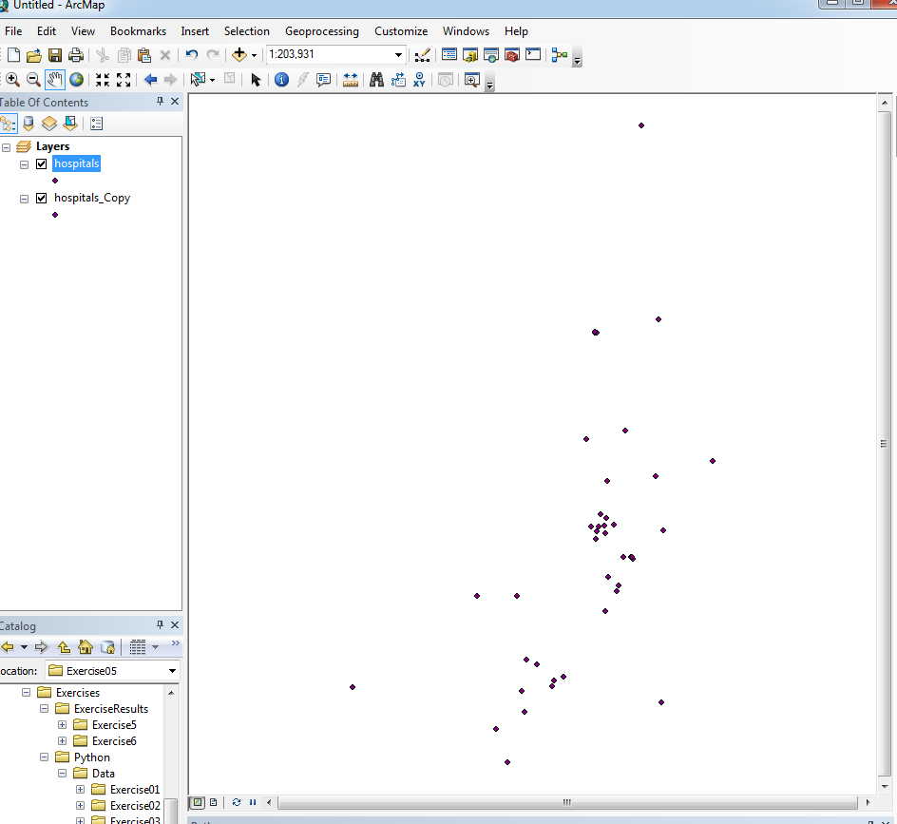

*Challenge 3*

Writing a script running the Dissolve tool with the parks.shp

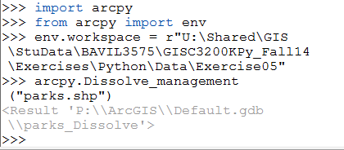

This is the outcome of the map.

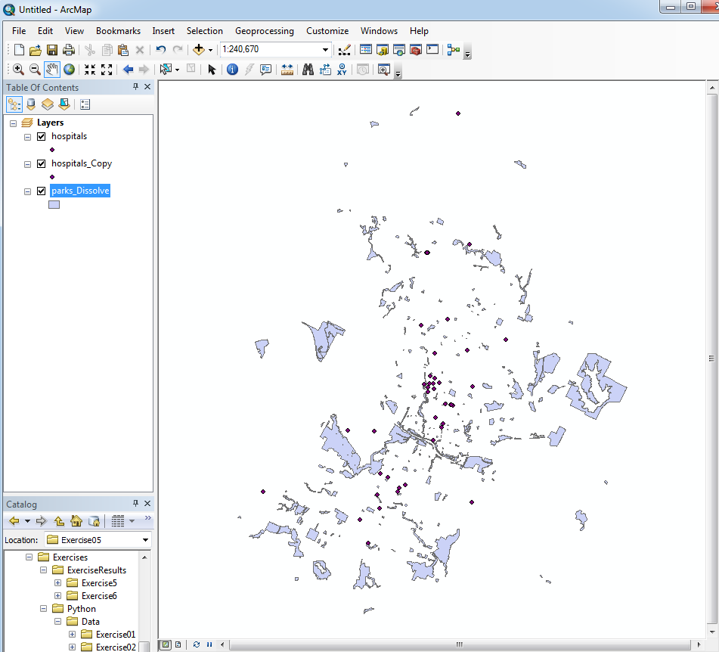

*Challenge 4*

Writing scripts to determine whether the following extensions are available: ArcGIS 3D Analyst, ArcGIS Network Analyst, and ArcGIS Spatial.

